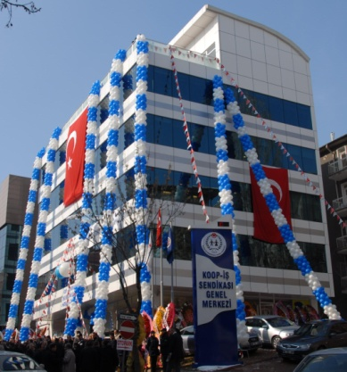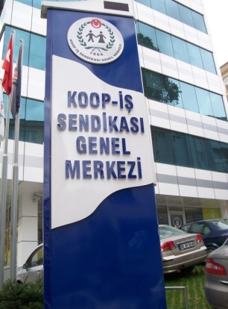
Koop-Is, operate in the cooperative, commerce, office, education and fine arts branch; affiliated to Turkish Trade Union Confederation (TURK-IS) and UNI Global Union.
HISTORY
Koop-Is founded in Ankara on August 02, 1964. Koop-Is became Turk-Is affiliate on 1970. Since Koop-Is founded, Koop-Is leaders played an active role for the establishment and the management of the Turk-Is.
ORGANIZATIONAL STRUCTURE
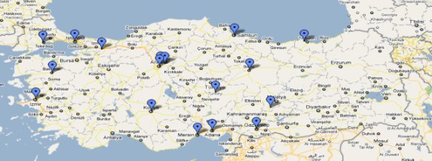
According to the latest Statistics of Labour and Social Security Ministry, Koop-Is has 46157 members at all around the Turkey.
Koop-Is operates 16 Branches in Turkey. Koop-Is Union headquarters and branch boards of directors are determined by votes of workers delegates in general assembly elections every four years.
At the last elections which held on August 7-8, 2010, President Eyup ALEMDAR, General Secretary Metin GUNEY, Financial Secretary Mehmet KARAARSLANOĞLU and Organizing and Education Secretary Osman AKSOY have been elected.
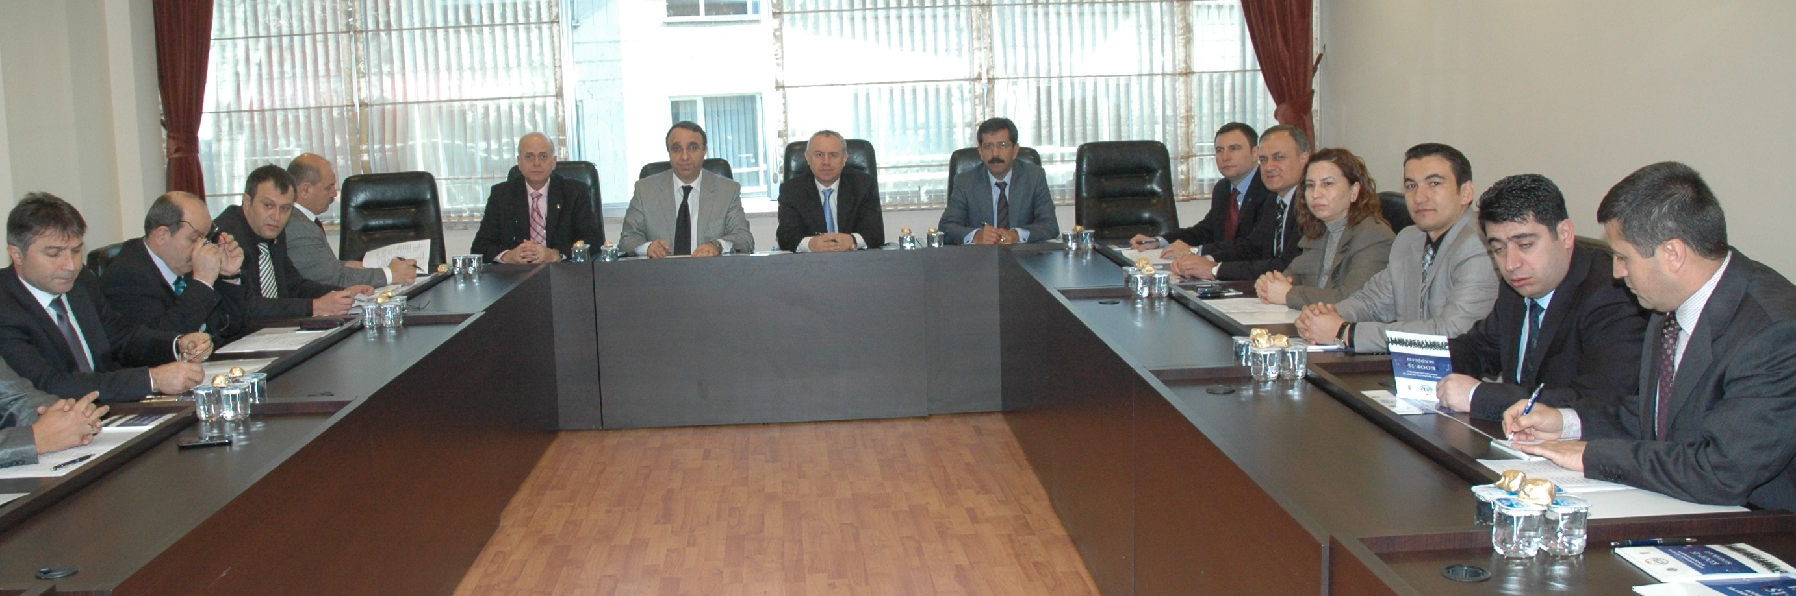
VISION
Koop-Is is one of the few unions to increase the number of members. Koop-Is is organizing both public and private sector. During the recent years Koop-Is started to organize at multinational retail companies.

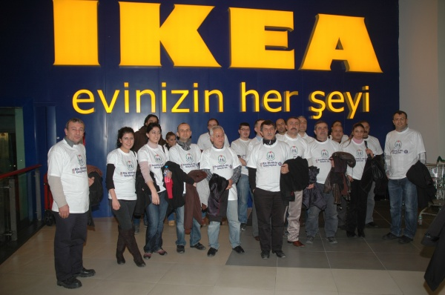
To empower Koop-Is and all the workers in Turkey and to achieve decent working
conditions by building and protecting workers rights and growing the sector.
Koop-Is give great importance on organizing and education.
WORKPLACES WE ORGANIZED
- The Central Union of Turkish Agricultural Credit Cooperatives,
- The General Directorate of Land Registry and Cadastre,
- Praktiker,
- The Oilseeds & Agricultural Sales Cooperatives Union of Thrace
- TAREKS Agricultural Products Import & Export Co. Ltd,
- Republic of Turkey Ministry of Education,
- General Directorate of Social Assistance and Solidarity,
- General Directorate of Security Affairs,
- Turkey Maritime Organization,
- Union of Service for Mayors
- Beet Planters Cooperative Union,
- The General Directore of Innovation and Education Technologies,
- Kupa Food Co.,
- Kocaeli Expo,
- Black Sea Oil Seeds Agricultural Sales Cooperatives Union,
- Taris Figs, Raisins,
- Cotton and Oil Seeds Agricultural Sales Cooperatives Unions,
- Turkish Maritime Foundation,
- The General Directorate of Eti Mine,
- Social Security and Labour Education and Research Central,
- Erciyes University,
- Gaziantep University,
- Gazi University,
- Yuzuncu Yil University,
- Sutcu Imam University,
- Korkut Ata University,
- İzmir Institute of Technology,
- Railway Workers Union,
- Post Office Telegraph, Telephone, Radio and Television Workers Union,
- Hotel, Restaurant and Entertainment Workers Union,
- Energy, water and gas workers Union,
- Sugar Industry Workers Union,
- Koop-Is Union.
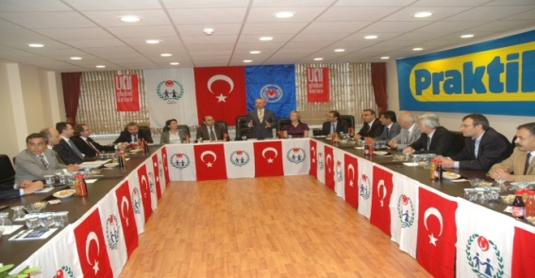

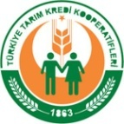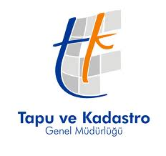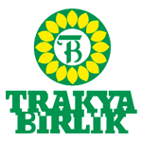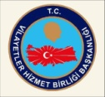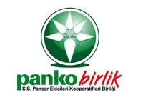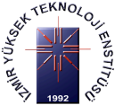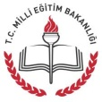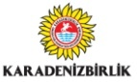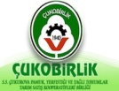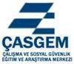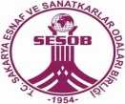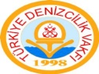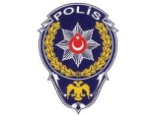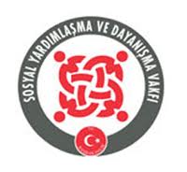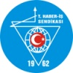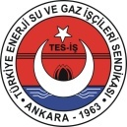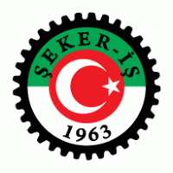

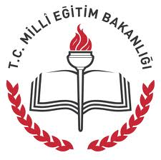

Union of Cooperative, Commerce and Office Workers of Turkey

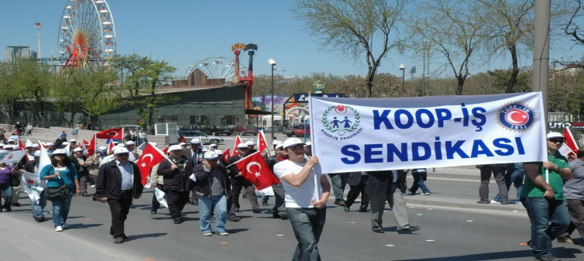

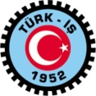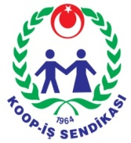
KOOP-IS UNION



KOOP-IS UNION

Özveren Sk No:6, 06570, Maltepe / ANKARA

Tel: +90 312 229 44 80
Tel: +90 312 230 08 55
GSM:+90 533 770 45 81-82-83
Fax: +90 312 229 58 36
Email: info@koopis.org.tr
www.koopis.org.tr
